U.S. Postage
Paid
Minoa, NY 13116
Permit No. 34

Minoa News

Event Issue 2021
Volume 18, Issue 2

Serving the People of Minoa for over 17 years

Mayor
William F. Brazill

Deputy Mayor
John H. Champagne

Trustees
John M. Abbott
Eric S. Christensen
Bobby Schepp

Clerk-Treasurer
Lisa L. DeVona


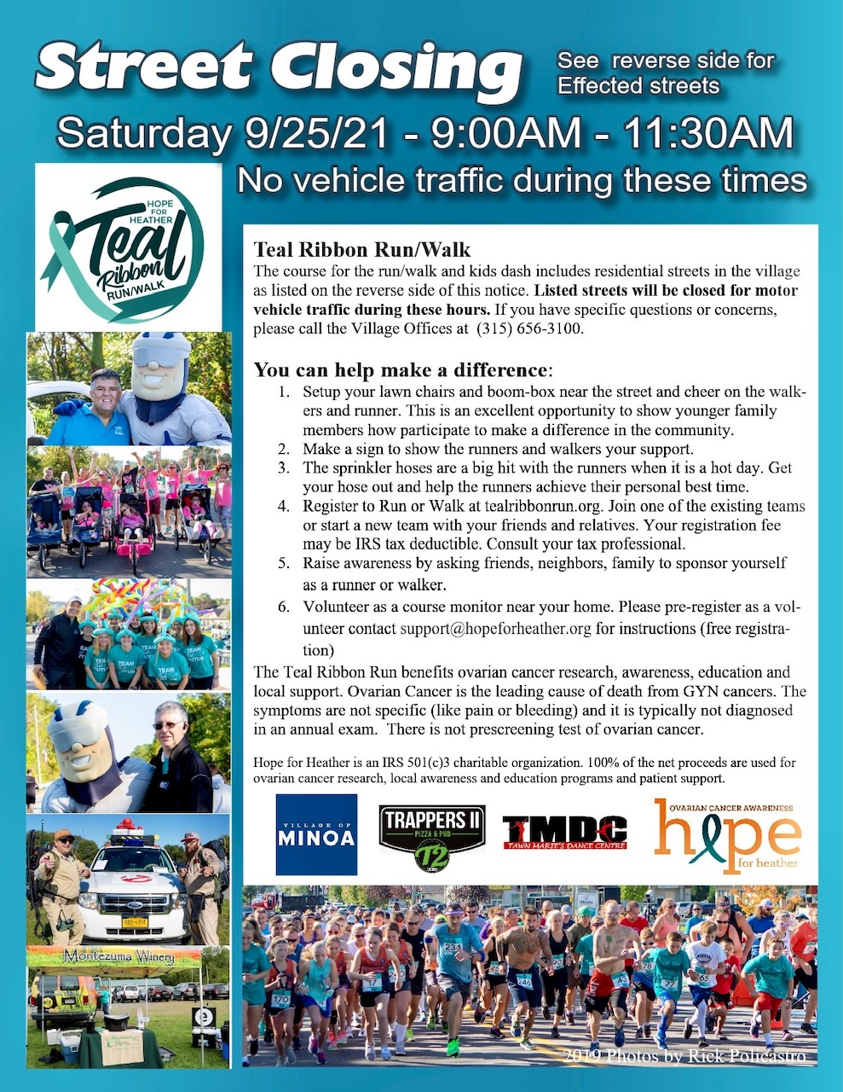
VILLAGE OF MINOA MEMORIAL MARCH

SATURDAY 9/11/21, 8:30AM
(from Lewis Park to the Minoa Municipal Building) MARCH FEATURING,
FIRST RESPONDERS FROM THE AREA
AND THE SYRACUSE SCOTTISH PIPE BAND

Board of Trustees
meet regularly on the
1st and 3rd Monday
of each month at the Municipal Building 6:30pm

Village Office
240 N. Main St.
Monday - Friday 8:00am - 3:30pm
(315) 656-3100
(315) 656-0825 fax


@villageofminoa


Village Taxes & Sewer Rent

Village of Minoa

WEB SITE
www.villageofminoa.com

